**MESA SURP RESEARCH REPORT**

**Farming Automation**

Kurtis Alder, Shane Barnett, Isaac Olson, Elizabeth Rosseett, Jamal Rouse, Daniel Wrzesinski, Madeline Wrzesinski

San Antonio College

Fall 2017 – Spring 1018

Table of Contents

**Table of Contents ...................................................................................................................2**

**Abstract …..............................................................................................................................3**

**Autonomous Farming ............................................................................................................4**

**Methods ................................................................................................................................6**

System Design ...................................................................................................................6

Floor Design ......................................................................................................................7

Software Design ................................................................................................................9

Tool Design ......................................................................................................................13

3D Printing ......................................................................................................................17

Part Design ......................................................................................................................18

System Testing .................................................................................................................19

**Results …..............................................................................................................................22**

Cost Analysis ...................................................................................................................22

Challenges …....................................................................................................................22

Programming issues ............................................................................................22

Connectivity Issues ..............................................................................................23

Manufacturing issues ..........................................................................................23

Saw Issues ...........................................................................................................24

Cutting Issues ......................................................................................................24

**Discussion ............................................................................................................................25**

Future Suggestions ..........................................................................................................25

Tools ....................................................................................................................25

Transplanting .......................................................................................................25

Harvesting …........................................................................................................25

**Conclusion …........................................................................................................................26**

**References ...........................................................................................................................27**

**Abstract**

The objective of this research project was to design, build, and test a low-cost system for remote propagation and relocation of seedlings in a containerized hydroponic garden.  To achieve steady crop production and effective growth patterns of various types of plants, constant monitoring and adaptability are required of a hydroponic system. When researching alternative watering, lighting, or other variable practices on different varieties of plants, having an automated system that can ensure timely maintenance in a secure environment is imperative for accurate results. This project produced a remotely-controlled system that is also portable and easily transplanted into various enclosed environments which can act to promote plant research world-wide and provide a reliable source of vegetation under climates unequipped for consistent plant growth. In situations where farmers are unable to continue production due to lack of assistance, an automated system would also be able to cover most labor-intensive tasks. This project augmented FarmBot techniques and technologies to suit Arduino and Raspberry Pi hardware. The finished system can plant seeds in a pre-specified location, and individually propagate the seedlings.

*Keywords: hydroponics, gardening, automation, propagation, robotics, agriculture.*

**Autonomous Farming**

Current farming efforts require hours of human intervention. During the propagation process alone the delicate seedlings will dry out and die within a matter of hours should they be at all forgotten or neglected. Watering and seeding may take an average of 2 hours per week for an amateur horticulturist who is always near their garden, however, without daily care and due diligence, the seedlings will quickly wither and die. Creating and proving a system that sees plant production from seed dispersal to plant maturation will reduce human labor costs, increase harvest quality, and boost harvest quantity per square footage.

According to Fred Gale, an agricultural economist with the Agriculture and Rural Economy Division, between 1982 and 1987, the number of farmers under the age of 25 decreased from 62,336, to 35,851. The population of elderly farmers rose from 400,000 to 447,000 (Gale, Rural Development Perspectives, vol. 8, no. 3). This increasing number in elderly farmers and decreasing number of younger participants is creating a need for labor in agriculture. Human labor is also a common source of production in current research and generation of plants including watering, planting, trimming, harvesting, monitoring, and troubleshooting in a timely manner. This immense human involvement is subject to human error, human contamination, and the inability to provide the listed resources, resulting in crop failure. More than that, in environments where research and production of foreign plants is arduous, human involvement becomes increasingly imperative and demanding. This lack of labor and need for precision and control brings about the goal of this research project, and the future of agriculture. Projects such as the Robotic Plant Propagation Machines by Invetech for Forbio have created similar-minded systems that automated aspects of farm production by 500% for equivalent labor applications (Invetech).

Automated agriculture is a budding circle in the food production community. In fact, Hands Free Hectare, a project based in the United Kingdom, is currently working on producing autonomous vehicles and drones that are able to maintain a fully automated farm. Just last September, in 2017, Hands Free Hectare was able to produce the first farm in the world to "successfully plant, tend, and harvest a crop without a single person ever setting foot in the field" (Feinfold, 2017). This farm was reportedly able to yield 4.5 tons of barley, and was a joint venture by Harper Adams University, and Precision Decisions. Automated sections of agricultural systems are becoming more common, but a fully automated process from seed to harvest with zero human interaction is a new and upcoming implementation of agricultural automation.

Many companies are focusing on automation in an outdoor farming environment where a great number of acres of farmland are growing the planet's resources. Plant research is often held inside of a controlled environment, unless the research relies on the environment of a specific location. The automated seeding system built at San Antonio College is able to work in an indoor or outdoor environment and will soon be able to read and control the pH, electroconductivity, and dissolved oxygen levels of the water-based nutrient solution sustaining the plants.

Past iterations of the hydroponic research done at San Antonio College have produced both stationary and mobile options for future hydroponic farming automation. The previous team developed a stationary automated hydroponic system capable of maintaining the water, lighting, nutrients, and dissolved oxygen of seedlings placed into the system using Arduino hardware and software. The goal of that project was to maintain already propagated seedlings, though there was still much human interaction needed in order to fully plant and harvest a crop, and it was difficult to transport. The goal of this research project was to develop a robot that would be able to plant, propagate, and relocate seedlings to a final stage growth area, and to create the robot in such a way that would make it easy for additional enhancements to be made.

**Methods**

**System Design**

The opensource FARMBOT project and online platform were the main design inspirations for this project. That project was designed to plant seeds in a raised-bed garden and preform watering and maintenance tasks robotically. The work described in this here details how that design was modified to aid hydroponic plant production.

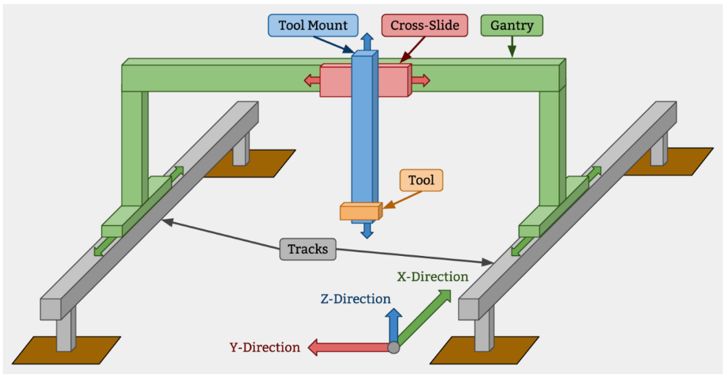

Fig.1: System Overview

Design of the machine frame was optimized for portability, cost, manufacturability, and ease of storage. A coordinated effort was also made to reuse existing equipment in the San Antonio College Hydroponics Lab. This last point led to the reuse of a shelving structure with a depth and length of 2ft by 6ft. Further reuse, this time of a LED grow lights, constrained the maximum grow area length to 4ft. After toolbays, drag chains, and frame members were integrated into the design; the overall footprint settled at approximately 26in by 61in.

To minimize cost, and unique component count, the aluminum extrusions used for the gantry guide rails was also used in the main structure. These extrusions offer great utility as they can be easily bolted onto at any point without the need to drill holes or otherwise deform the frame member. This ability enables modifications at nearly any stage of assembly with ease. Various wood, plastic, and metal products were also considered, however, these materials either did not meet the moisture requirements or required extensive design time to integrate into the gantry assembly.

**Floor Design**

Initially, the floor of the machine was envisioned to be a single shallow tray that would be bolted to the base frame. The main motivation for this tray was to contain spills from the watering tool. As design work progressed, however, it became clear that there were no existing commercially available trays that fit the full machine footprint. Making a custom tray was also investigated but ultimately ruled out as the tooling needed for a mold would have consumed too much project time to construct.

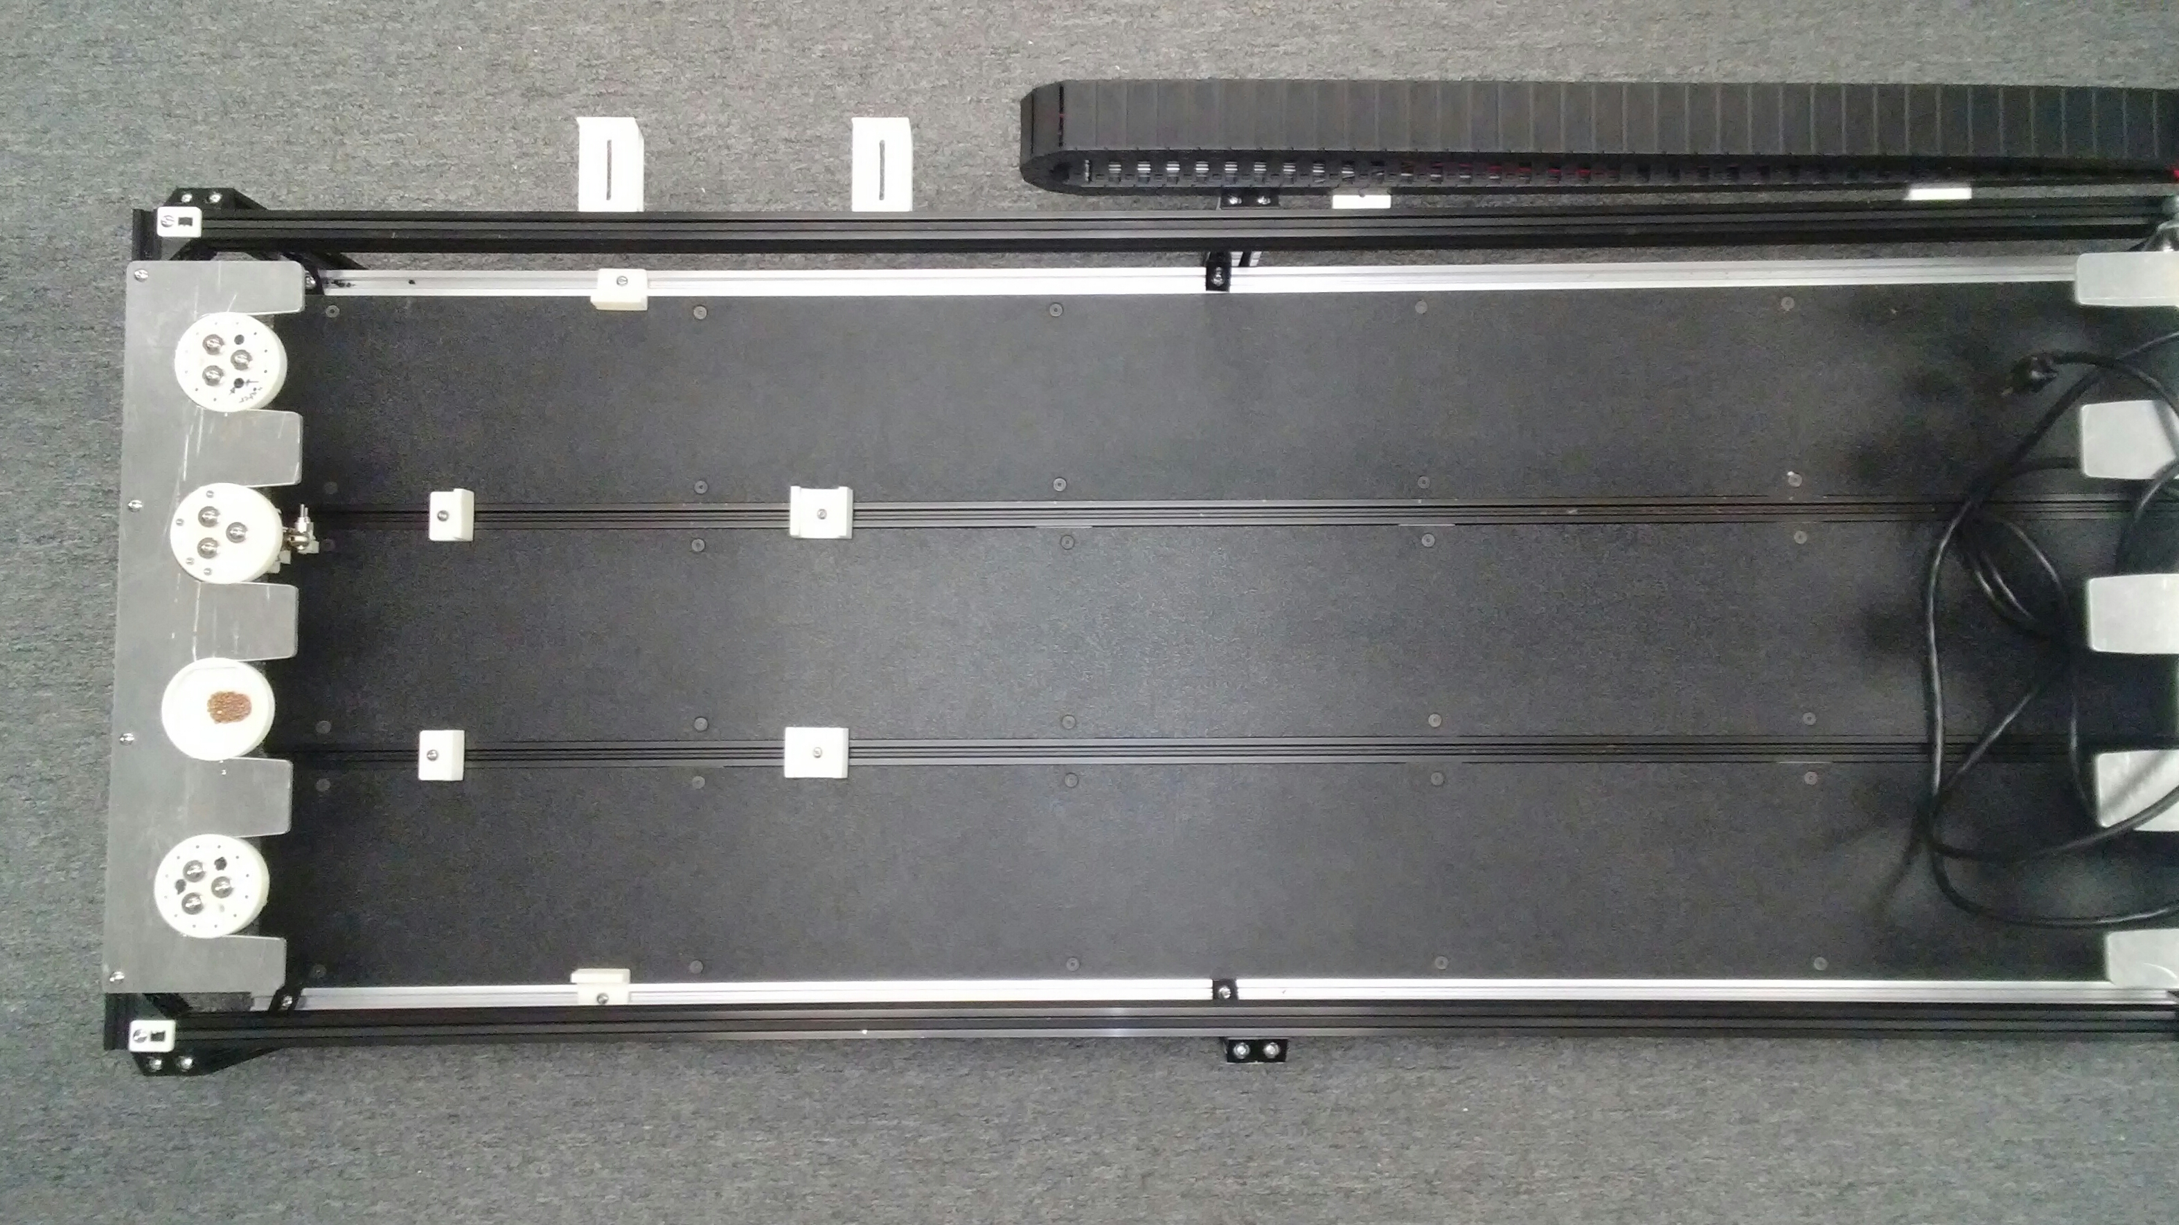

Fig.2: Top view of San Antonio College FarmBot

At this time, the team recognized the need to increase the modularity and upgradeability of the machine. Because of this, two decisions were made: first, the base of the machine would not be watertight because smaller standard greenhouse trays would be used instead. Also, a more precise watering tool was developed, minimizing the risk of overspray. The second decision was to use the base of the machine to increase the modularity of the machine. A series of spacers and supports was developed to securely mount various trays and tools to the four rails that run the full length of the machine. To complete the machine base, the gaps between the rails were covered by pieces of ABS plastic which were held in place by 3D printed brackets.

**Software Design**

The FarmBot organization has built, and actively maintains, a web secure app that allows users to remotely monitor and control any connected FarmBot. In this case a "FarmBot" is any Raspberry Pi 3 and Arduino Mega combination. As long as the FarmBot OS is installed on the Raspberry Pi 3 the FarmBot can connect to the web app. This lack of physical requirements such as a maximum or minimum length per axis, or even a constraint on the number or axes, has led to a veritable zoo of robotic frameworks. While most FarmBots seem to keep with the traditional three axis gantry and default software, further customization is possible because the FarmBot organization has opensourced all code relating to the web app and machine OS. While it requires a heavy amount of code experience, having access to the source code enables users to host custom control code on their own servers.

For this project the default FarmBot server and OS were used, however, there was still a fair amount of programming required to get the machine functioning correctly. The main goal of the teams' programming efforts revolved around precise and repeatable positioning of the robot arm. With the FarmBot web app there are two ways to interact programmatically with connected machine; either with a graphical coding interface or via third-party plugins, called FarmWare.

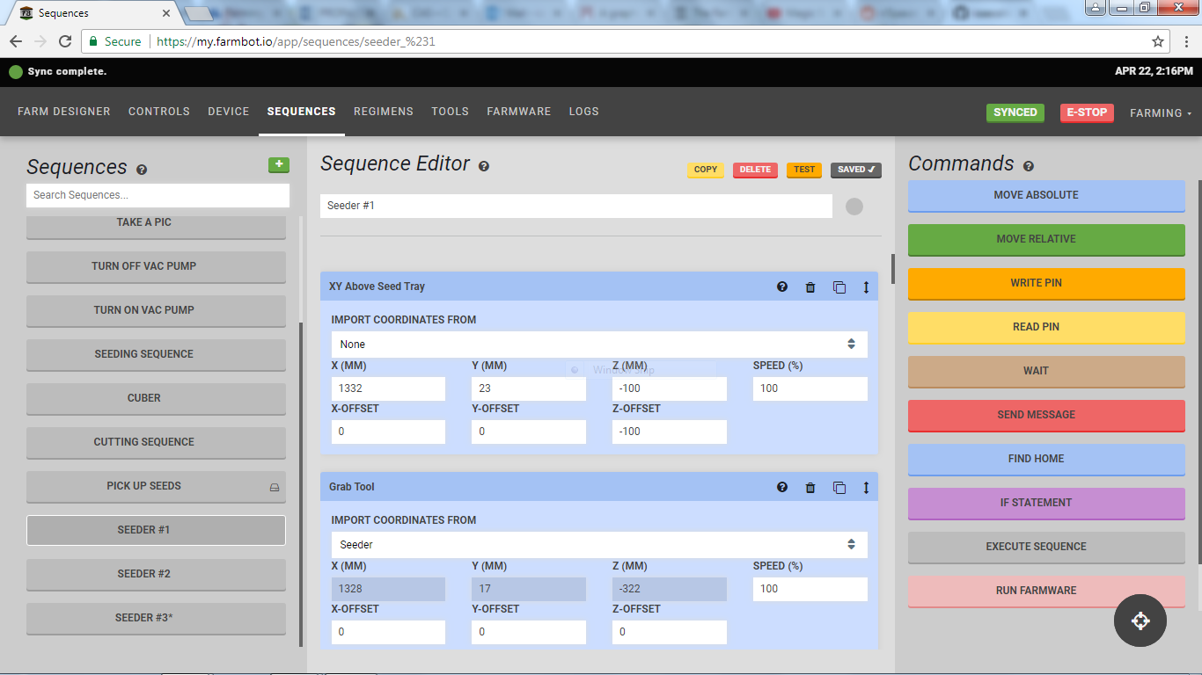

Fig.3: Screen capture of the FarmBot Sequence Editor

The graphical interface, or Sequence Editor, allows a user build control sequences by dragging and dropping visual code blocks. Blocks consist of typical programming logic operators as well as custom functions including MOVE RELATIVE, MOVE ABSOLUTE, READ PIN, and WRITE PIN. Once placed, attributes of the blocks can be modified to suit the desired outcome. For example, a MOVE ABSOLUTE block will have X, Y, Z attributes for the destination coordinate. Sequences are executed in the sequential order of the code blocks they contain, and they can be triggered by other sequences or by time and date specific "Farm Events." While the Sequence Editor is helpful for users with low code literacy, it was found only to be ideal for simple operations requiring a few steps. Such operations include activating/deactivating the vacuum pump and tools, simple movement of the machine, and taking photos. Attempts to use the Sequence Editor to construct more complex sequences were met with frustration; due primarily to the apparent lack of the ability to loop. Without programming loops, the burden to keep track of potentially hundreds, or even thousands, of sequences becomes prohibitive. However, this is exactly the problem that FarmWare solves.

FarmWare is a type of third party addon to the FarmBot web app. Primarily FarmWare are written in the Python programming language, however, other languages can also be used. The main advantage of FarmWare is that it exposes the entire FarmBot application programming interface (api) to the user. This means that a user can now program specific actions for the machine that the developers may never have envisioned.

Initial tests into using FarmWare for this project revolved around manipulating the distribution of plants in the Farm Designer portion of the web app. The tests involved visually showing a circle of plants intended for future planting. FarmWare was also developed and tested for seeding.

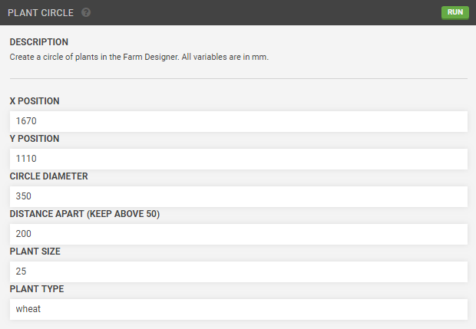

Fig.4: Example of user interface auto-generated for FarmWare.

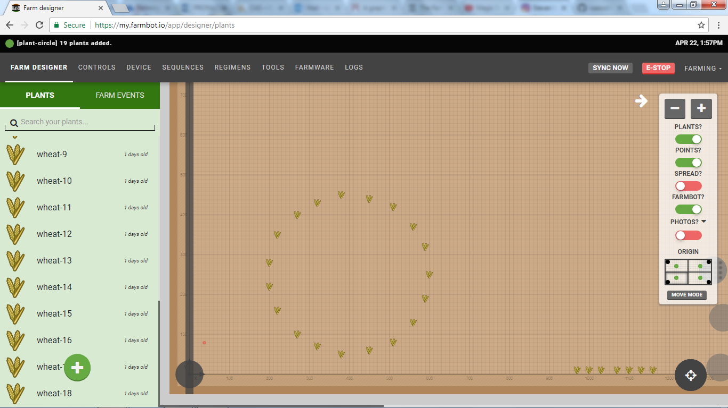

Fig.5: Results of Plant Circle FarmWare.

**Tool Design**

Several tools were designed and tested to augment the existing FarmBot toolset. These include an improved watering tool and cube transplanter.

The existing FarmBot watering tool was designed for hydrating plants in a raised bed garden. While it is relatively precise, the water is dispensed in a pattern similar to a low-pressure showerhead. To ensure even watering of plant seedlings during the propagation stage, an improved watering tool was developed. During the propagation stage the seedlings are contained in a biodegradable foam growth media placed in a tray. The base of the machine is not watertight; therefore the tray is the only means of containing water once it has been dispensed. This means that there is very little room for error in the programmed placement of the watering tool. The need for precision also dictates that the dispensing nozzle radius and water pressure must be quite small to minimize overspray. The design that emerged from these requirements consists of a single 3d printed part that includes a long, narrow, water nozzle and universal tool mount interface.

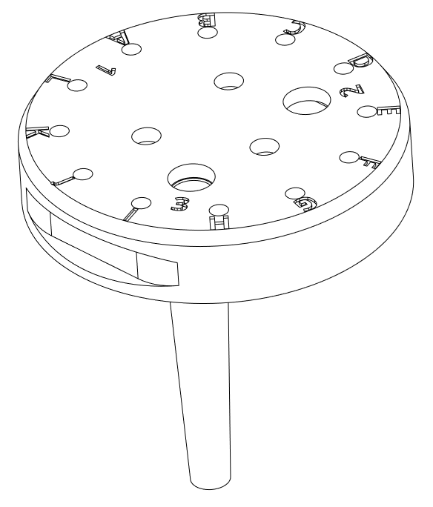

Fig.5: Improved watering tool

The purpose of the transplant tool is to extract individual seedlings from the growth media and move them to a long-term growth apparatus. Such long-term growth solutions could include larger pots or complete hydroponic systems. During the extraction phase the tool must cut out an individual cell of growth media, grasp onto it without disturbing the plant or its neighbors, and then finally retract to a safe distance. Cutting the foam requires minimum force as its density is very low. Also, existing grooves in the foam reduce the cutting cross-section, further reducing the required cutting force. To ensure a clean cut, the leading edge of the tool was designed to be tapered. This feature ensures that maximum force per area is applied upon contact with the foam, and it neatly severs and divides the foam so that crushing is avoided.

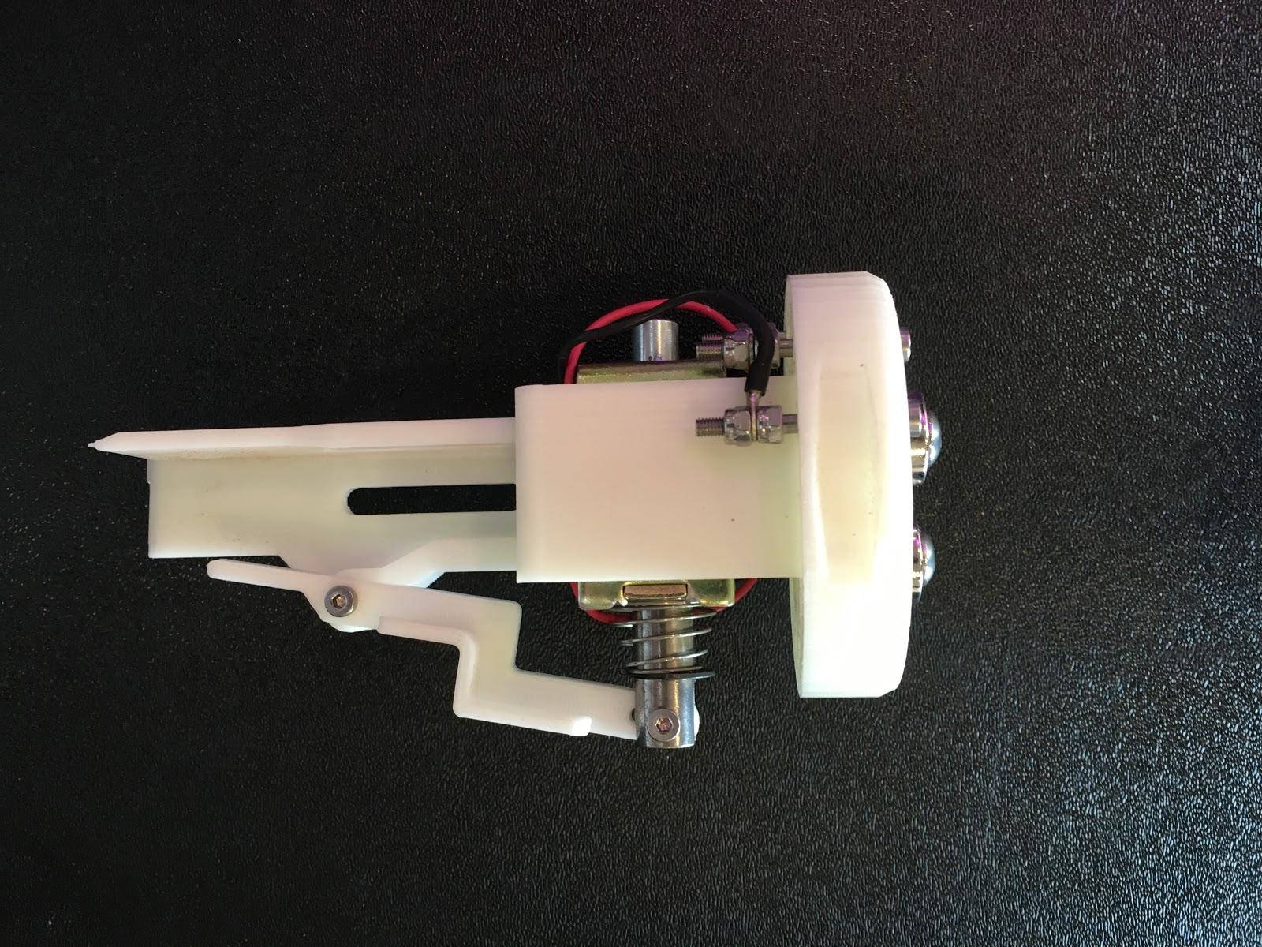

Fig.6: Transplanting tool

Grasping of the foam cells is accomplished by the use of a solenoid and lever arm. When the solenoid is activated it retracts, pulling the long end of the lever with it. This action opens up the jaws of the transplanter. Closing of the jaws, or grasping, happens when the solenoid is deactivated. This occurs because the solenoid is spring loaded, once deactivated the spring pushes the long end of the lever away. The design could have been reversed; with different geometry grasping could occur upon activation of the solenoid. This option was considered, however it lost favor when a power loss scenario was envisioned. If grasping were to occur on activation, then a loss of power during transplantation would result in a plant being dropped in an uncontrolled manner. Grasping upon deactivation ensures that if power is lost the "payload" is still safe.

On accident, one of the solenoids purchased for this project was left activated for over twenty minutes. Upon realizing this, it was observed that the solenoid had become too hot touch. An average transplant time should be no greater than two minutes, however, when preforming repeated transplants of an entire tray (104 cells) the solenoid could become too hot. The structure of the tool is made from 3d printable thermoplastics; the these include polylactic acid (PLA) and acrylonitrile butadiene styrene (ABS), both of which have relatively low melting points. In 3d printing, a low melting point is ideal because it leads to less power required to heat the plastic, however, this attribute can become a liability. Prolonged exposure to heat near the materials melting point could cause the structure of the tool to warp and sag over time, leading to misalignment of the various tool components. The ramifications of heat buildup made it apparent that the solenoid should be activated a briefly as possible. This only further reinforced the decision to close the transplanter jaws upon deactivation.

**3D Printing**

This project made use of the available 3D printers on the campus of San Antonio College, including the MakerBot Replicator printers at the MESA Center Lab and Technology Store. Attempts were also made to print with the larger MakerBot Z18 printer in the Media Center, however, configuring that printer proved to be a futile effort. Updated software and firmware were installed and the test prints came out brittle due to old filament. When new filament was installed, the test prints continuously came out warped, and the prints would not stick to the surface of the printer while they were being processed, so the resulting prints were deformed and unusable. It was decided that the platform of the 3D printer needed to be replaced.

While prints were often simplistic in function; design and application were many times more complex than initial inception. As a result, most if not all designs were tweaked with multiple versions being at least modeled, and oftentimes printed before moving to the next design. Unfortunately, some ideas had to remain as such because parts simply became too complex to print in a timely manner or were unreasonable in resources used. While most complex parts had to be whittled down to multiple parts or just a very basic design, one component that got around this for the most part was the grabber arm previously talked about in the tools section. Though it's printed parts were two pieces, the main body, not including the lever, was able to be printed quite easily by employing self-supporting design strategies and a straightforward, straight standing structure. Using minimal support material, the grabber arm's final iteration including lever and main body took only 3½ - 4 hours to print.

In general, 3D printing takes longer to process parts compared to other manufacturing practices such as computer numerical control (CNC) machining. However, it is cheaper and more efficient for complex parts due to its additive manufacturing nature as opposed to the more common subtractive manufacturing processes. When producing 3D printed parts, a majority of the time spent producing them goes into the design process. The printing itself takes hours at a time, and when creating a new part, a new or updated design may occur even during the printing of the part. Scheduling printing within the hours of the printers' availability allowed, on average, one to two prints per day, so there were still some limitations and time constraints in 3D printing, though these constraints are common to most independent developers.

**Part Design**

Limit Switches have been utilized for the X and Y axes to ensure the FarmBot stops moving before reaching the end of the extrusion railing. To attach the limit switches, 3d models were designed and printed to be secured near the boundaries of the FarmBot (Fig.7). The switches are only used at the home positions of the X and Y axes to let the FarmBot know when it has reached home. From "home", the FarmBot knows how far it is from the opposite edges of its extrusion. This is possible because the sequences have been coded in a way to solely reference home when moving a number of millimeters in distance. In addition to limit switch attachment pieces, stopper models were also made to work in tandem with the switches to activate the switches upon impact. This was placed to accurately signal when "home" was reached on the X and Y axes.

**System Testing**

Many of the key functions this machine preforms require precise and accurate positioning of the arm. Throughout the assembly process, tests were performed to verify that design decisions were supporting performance goals. The original FarmBot design, which inspired the team to undertake this project, included a single steeper motor for every axis except for the X. Like most large CNC gantry machines, that X-axis is driven by two stepper motors, one at each end of the gantry. As a cost reduction effort, it was thought that a single motor could be used on the proposed system because the width of the machine would only be 24 inches. It was hoped that a reduction in width would correspond to a reduction in the torque produced by the friction of the wheels on either end of the axis. With the reduced torque a single motor would be sufficient to pull the gantry along. However, upon assembling and the motion in the X-axis was tested and it became apparent that this hypothesis was incorrect. As the gantry traveled down the length of the Z-axis, it was observed that the side of the gantry without a steeper motor lagged as much as half and inch behind the other, regardless of travel direction. This gantry twisting motion cast doubt on the accuracy of any location on the X-Y plane. To address this issue, attempts were made to reduce the friction of the wheels on the lagging end of the X-axis, however, the lasting solution came when another motor was added to the axis.

After installing the Y and Z axes, they were promptly tested individually for accuracy and no apparent issues were discovered. However, when testing movement that required simultaneous motion along all three axes, it was observed that motion proceed in a halting fashion accompanied by a loud grinding and squealing noise, aptly described as "a train" by one lab attendant. Upon inspection, it was theorized that the failed motion was a result of the compounding vibrations of each axis. Individually, each axis' vibrations seemed to be within acceptable levels, however, when in unison, they amplified each other, causing belts to loosen and slip on drive gears, leading ultimately to the halting motion and distressing noises. More testing followed after aligning re-aligning each steeper motor with its attached gear or drive screw, tensioning the drive belts, squaring the gantry, and adjusting the friction of the guide wheels. Some of the same symptoms were observed, albeit not as often and at a lower volume. This tweaking and testing routine continued for several more rounds until the symptoms were greatly reduced. The final fix to the vibration induced issues came when the speed and acceleration profiles of each axis were heavily customized. In the FarmBot web app, each axis can be tailored to have a specific min/max speed and an acceleration distance. It had been observed that most of the noise and halting action took place during acceleration events. By lengthening the acceleration distance, acceleration itself which in turn greatly reduces the forces causing vibrations. However there is a downside; reducing the overall speed and acceleration of an axis increases the time required to perform a given motion.

At this time, it was also observed that the NEMA 17 stepper motors purchased for this project were relatively loud and, while vibrating slightly, also contributed to the vibration issues. To solve this problem the team microstepped the motors. Stepper motors work by moving only rotating a step, or a tiny portion or a rotation, at a time. Doing this rapidly presents the illusion of continuous, smooth movement. A typical step is 1.5 degrees long, making 240 steps per revolution. Microstepping smooths out the somewhat rough stepping routine by adding virtual steps between the physical steps. This effectively shrinks the step size which eases the transition between physical steps. The motor control board in use for this project, a RAMPS Rev 1.4, and the stepper drivers both support the ability to microstep down to a 1/16 of a step. This means that a motor with 240 physical steps can have up to 3,840 microsteps.

On the RAMPS control boards, microstepping is accomplished by jumping a series connector pins. Testing to apply microstepping to the San Antonio College FarmBot began by attempting to implement 1/2 step. This resulted in a noted drop in motor vibrations and noise output. The trend of decreasing noise continued to be observed when preforming tests of 1/4 step and 1/8th step. However, with each decrease in step size a proportional drop in axis speed was also noted. Apparently, this is a common issue resulting from the increased current draw of microstepped motors and limited current supply. The power source in use with this design is able to supply 12 volts of direct current power at up to 29 amps. When the motors are in operation the all share from current supply, along with the logic control boards and any other electronic components. The slowing of each axis occurs when the draw of the current for each motor surpasses the power supplies output. When this happen, the motor does not have enough current to maintain the desired speed and chugs along as fast as the available current will allow.

This same slowing issue cropped up again when movement along all three axes was tested. Unsurprisingly, the power supply lacked the current necessary to drive four microstepping motors running at full speed. To fix this issue a larger power supply could be used, however, the speed is not slow enough to justify this added expense.

Once the vibration issues were addressed testing began on the seeding tool. As the name indicates it is used to plant seeds in the growth media. This tool was a holdover from the original FarmBot design. After reviewing the design, and seeing no need to change it, the CAD model of the design was downloaded from FarmBot organization's OnShape page and promptly 3D printed. The seeding tool consists of a 3D printed frame that has mounting holes for magnets and other hardware used to securely connect to, and pass data through, the robotic arm. Seed pickup is accomplished by vacuuming seeds up to a large diameter needle attached to the base of the tool. The seed is held in place because it's diameter is smaller than the diameter of the needle. Once the tool has been moved to a planting location, the vacuum is turned off, and finally the seed falls into place.

Initial test of the seeding tool revel that there was insufficient vacuum force to hold seeds. Two issues were found to have contributed to this. This first was that the chosen needle size was slightly too small for the test seeds. A needle with a larger internal diameter was fitted to the tool and a stronger, although insufficient, vacuum force was observed. Finally, while searching for sources of leaking in the vacuum plumbing, it was observed that a stream of air was blowing toward the needle tip. Upon further investigation it was found that the exhaust outlet of the vacuum pump was blowing directly onto the seed that was being vacuumed. This downward force counteracted the vacuum force and led to seeds being dropped. This issue was quickly resolved by diverting the exhaust air through a hose attached to the pump outlet.

**Results**

**Cost Analysis.** The total cost wavers around $2,000 depending on what tools, parts, or materials are available. The system can handle four standard 1020 greenhouse trays which can have up to 104 cells each, for a total of 416 seedlings. Open ends of the machine allow trays to be pushed off leading to no real limit to the number of trays that can be seeded in an assembly line.

**Challenges**

**Programing Issues.** As discussed under *Software Design*, a major challenge occurred in creating more advanced programs involving variables and loops. The original FARMBOT was designed to use a graphical user interface that allowed inexperienced programmers to implement their actions using mock-programming. However, these features created an easy way to do simple tasks, but a painfully long way to do more complex tasks. A flowchart example of this process can be seen in Fig. 8 at the bottom of this report.

**Connectivity Issues.** During the course of the project, initial setup was inhibited by a lack of reliable internet connection. The internet normally used within the lab that the project took place requires a username and password in order to have access. However, the machine could only communicate using open internet connections due to the lack of username availability for the machine, and the setup process when creating a my.farmbot.io account.

**Manufacturing Issues.** Access to reliable 3D printing was limited to the availability of the technicians and the machines. Without access to an in-house 3D printer, the team often had to reroute and continue in other areas of the project while the printed parts were building a backlog. With a wait time on 3D prints, it was also difficult to manage the time needed for redesigning a part that proved less than optimal once it was printed and fitted.

One of the problems with a certain 3D part had to do with its overall complexity. The intent of its design was to guide cables away from the moving Z axis, and it was attached to the Y axis. However, when attempts were made to print it, the lack of a common base, many overhangs, and extrusions in all dimensions proved too complicated to support even with excess support material. Therefore, as a part non-essential for operation, it had to be abandoned until future revision.

**Saw issues.** The machine shop annexed to the MESA Center at San Antonio College provided most of the project's machining needs. However, when cutting the aluminum extrusions, the only saw blade available was a wood-cutting blade. After doing research, a multi-purpose blade was purchased and used to cut the 5/16-inch-thick aluminum plates. The saw used was able to reliably clamp and hold rectangular fittings, but when moving into more complicated and angled shapes, new, unconventional methods of fastening were applied. These methods proved dangerous when, during one cutting session, a metal piece was not secure enough to the saw mount and flew from the saw, barely missing the participating team members, and off of a brick wall nearby.

**Cutting Issues.** When cutting the gantry wheel plates, there was no access to precise and affordable aluminum cutting mechanisms. Ideally, the design of the wheel plates would have been cut using a laser cutter. However, those parts were instead cut using a drop saw and a drill press after being manually scribed. These efforts resulted in alignment issues across the machine. In fact, the eccentric spacers used to correct these efforts still cannot cover the errors produced by manual machining. Because of this, the machine cannot move at speeds higher than ¼ steps before vibrating excessively and producing copious amounts of noise. There are times when some of the wheels on the y-axis are not even touching the railing.

**Discussion**

**Future Suggestions**

**Tools.** Quick access to reliable tools is a necessity for future development. Exacting measurements must be made and produced with exacting machines. Relying on the human eye and a steady hand results in a buildup of part measurement discrepancies, which leads to overall build inefficiency. Relying on a 3d printer with limited availability causes unintended stalls and wait times in building the machine.

**Transplanting.** A transplanting tool was designed during this project, but halfway through the design process, larger foam cubes were decided upon and the redesign of the transplanter was not constructed. The core cutting aspect of the design has been verified to work, but minor readjustment to the size of the grasping mechanism must be implemented for testing of this tool. This tool was discussed in further detail within the *Tool Design* section of this report.

**Harvesting.**  Efforts to produce a cylindrical reservoir for a hydroponic nutrient film technique were made to a point where only a few parts were needed in order to complete the build. The reservoir will contain the nutrient-water solution necessary to feed the post-propagated plants. A full design of the part was created, however efforts to produce the part were abandoned in order to complete the initial planting phase of the project's automation goals.

**Conclusion**

This project is one of a growing number of ventures into agricultural automation. With a rise in technology and a drop in agricultural labor participation, this machine helps further the efforts of closing the agricultural labor gap. The upgradable nature of the design of this machine ensures that future developers will be able to modify it to their individual gardening needs, be it sustainable farming, plant research, or personal enrichment.

**References**

Invetech. Forbio: Robotic Plant Propagation.<http://www.invetech.com.au/portfolio/life-sciences/robotic-plant-propagation/>

Gale, Fred. “America's Aging Farmers: Who Will Take Their Place?” *United States Department of Agriculture: National Agricultural Library*, USDA Economic Research Service, 1 Oct. 1993, naldc.nal.usda.gov/download/IND20388152/.

Feingold, Spencer. “Field of Machines: Researchers Grow Crop Using Only Automation.”*CNN*, Cable News Network, 8 Oct. 2017, [www.cnn.com/2017/10/07/world/automated-farm-harvest-england/index.html](http://www.cnn.com/2017/10/07/world/automated-farm-harvest-england/index.html).

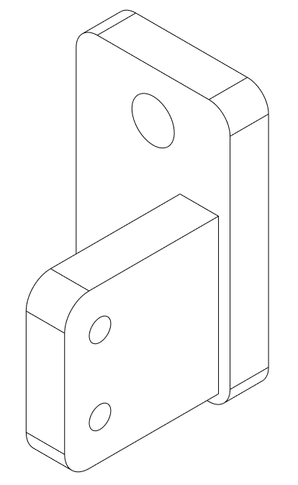

Fig. 7: X axis limit switch mount

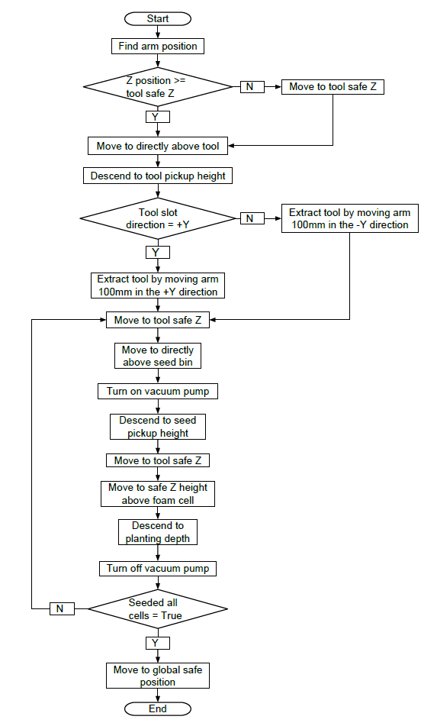

Fig. 8: Seeding sequence program flowchart.

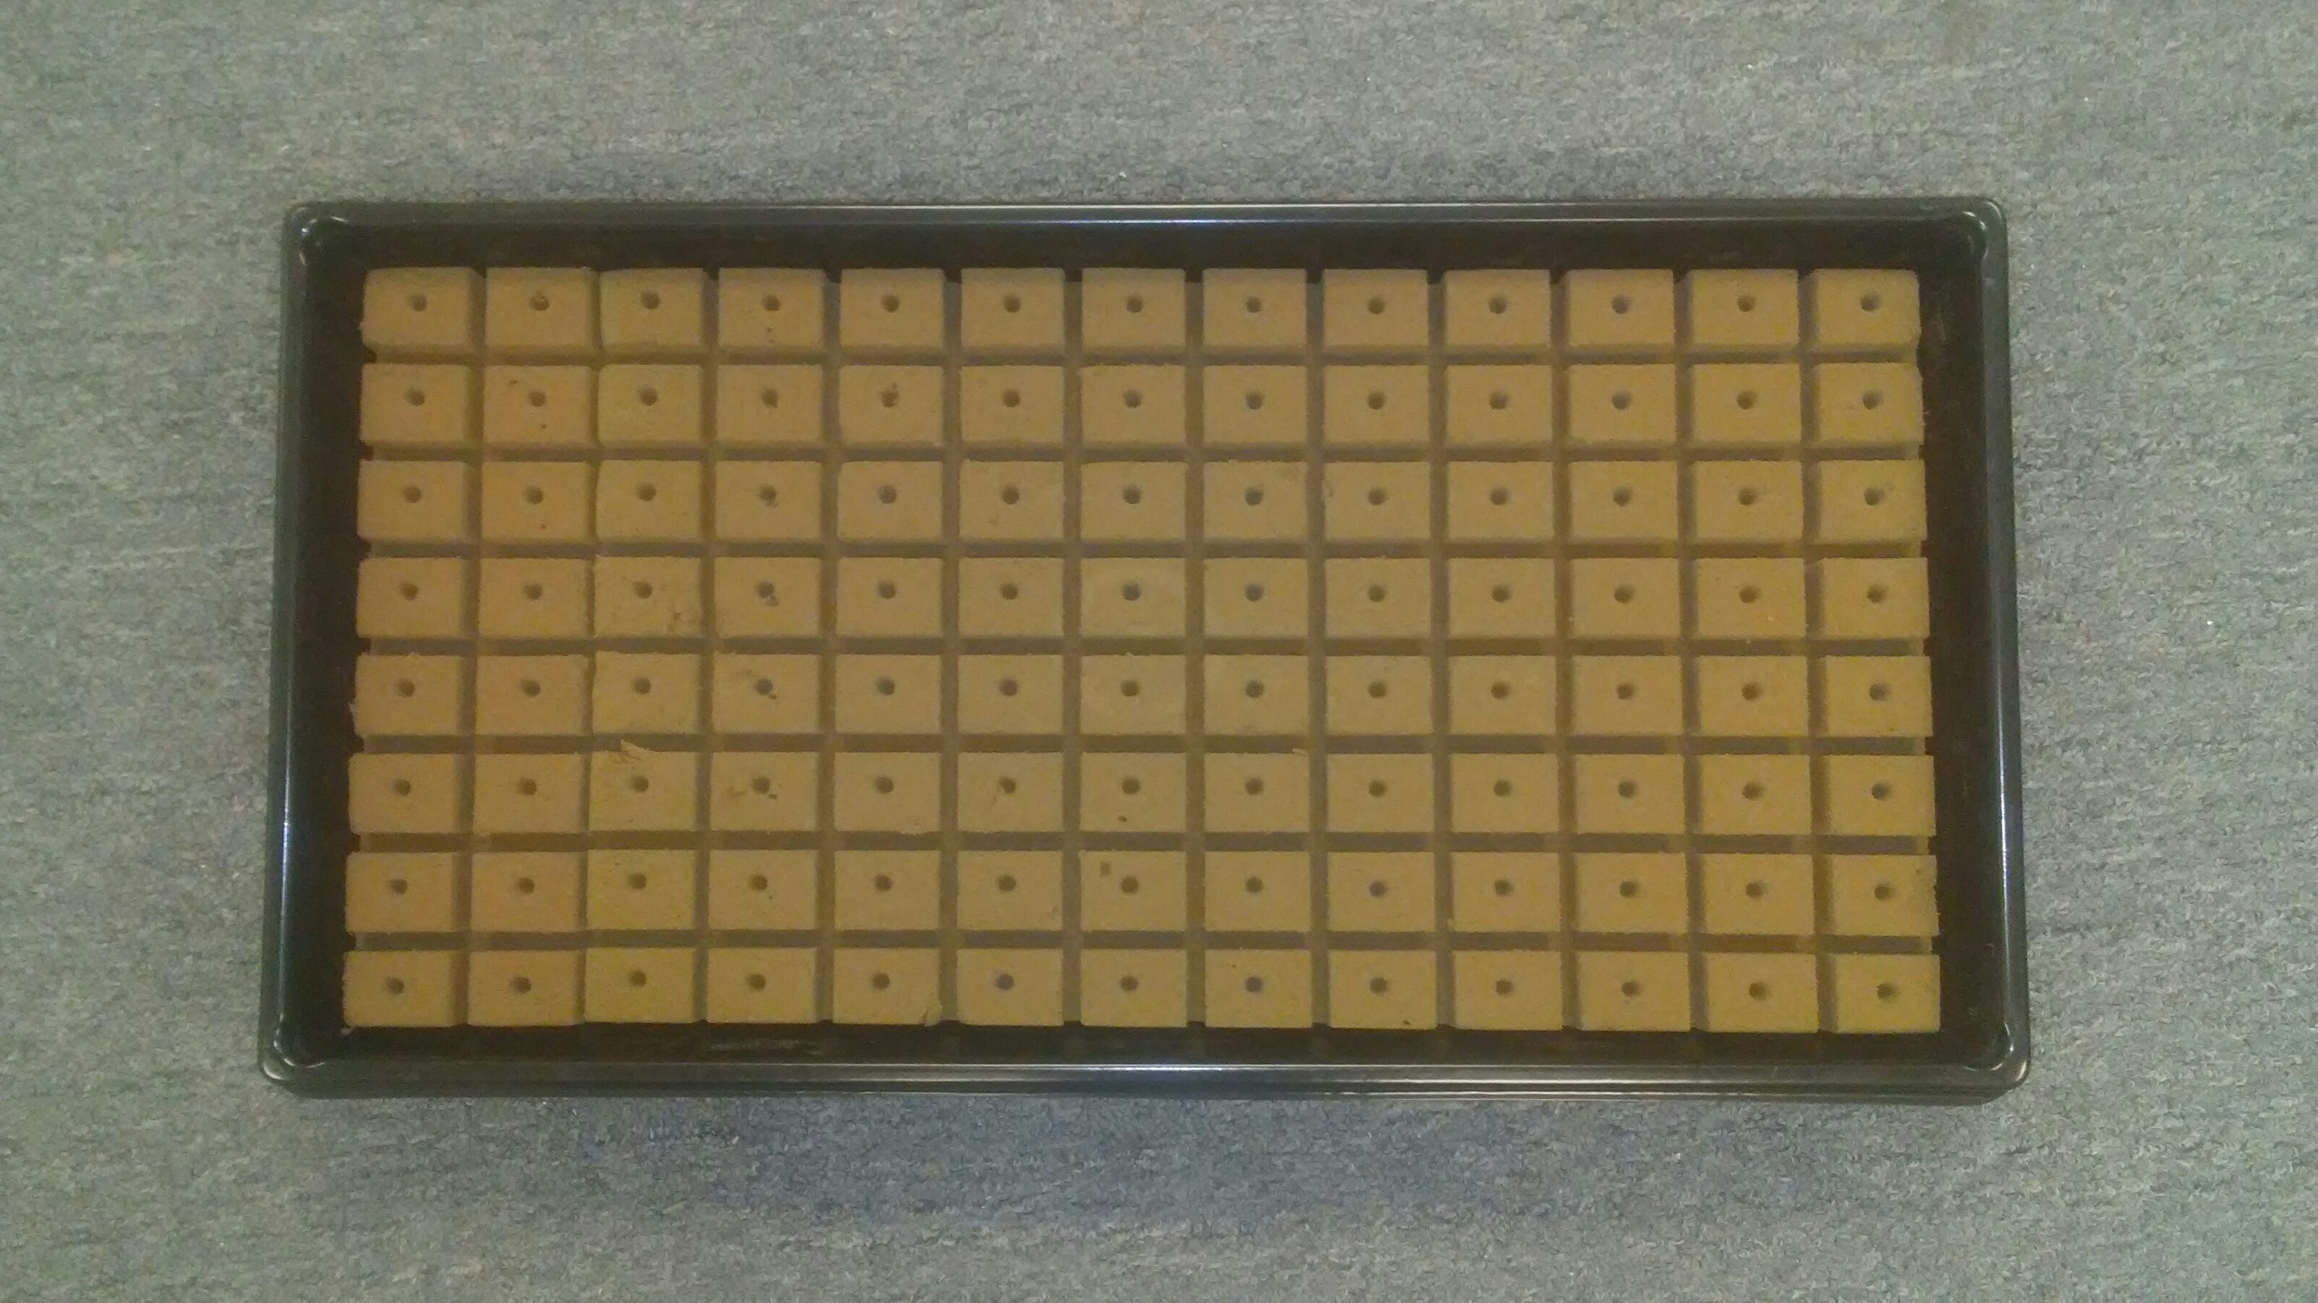

Fig. 9: Seed tray. Shown with 104 cell sheet.

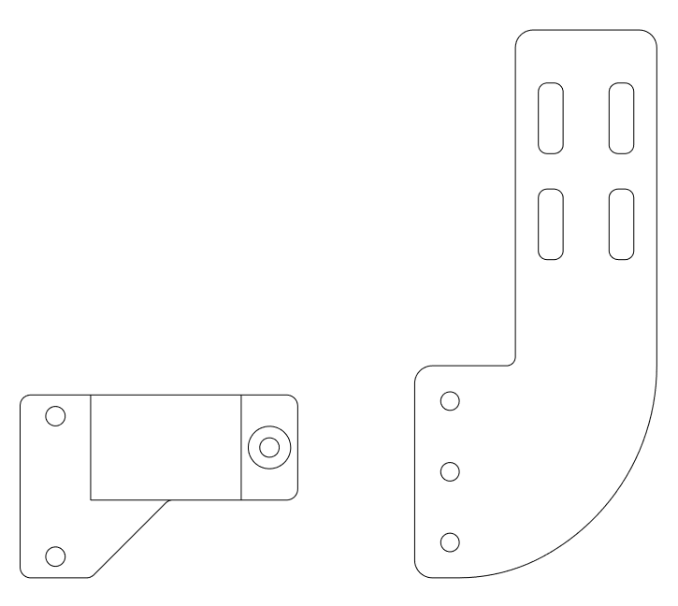

Fig. 10: Improved vacuum pump(Left), original vacuum pump mount (Right).

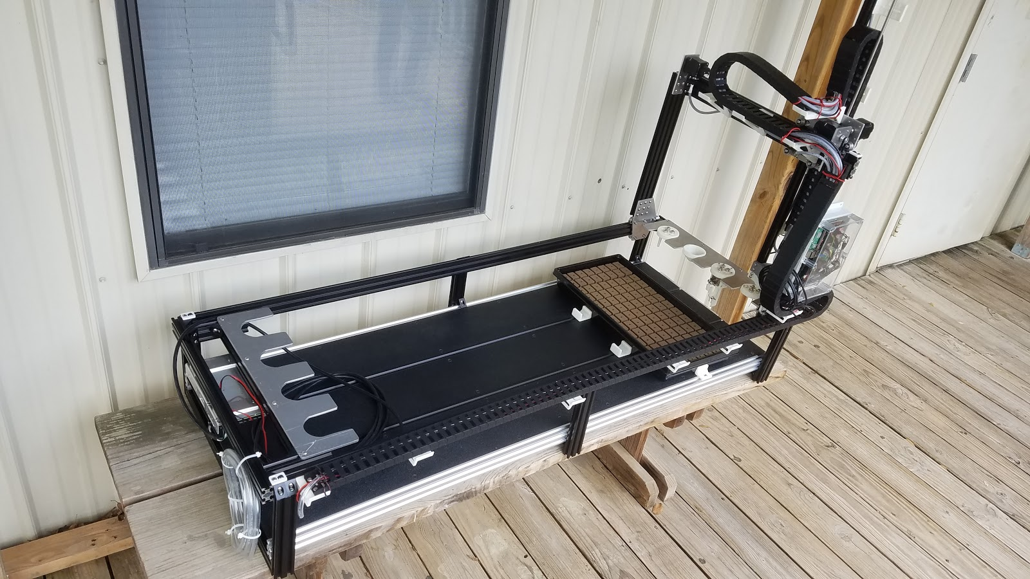

Fig. 11: Completed San Antonio College FarmBot